 | Volcanic hazards: solution to the exercise | 

Introduction
This details the hazards that face the area around the volcano described in the worksheet. The evidence given in the worksheet suggests that the volcano is most likely to erupt explosively, and that ash is more likely than lava. However, the hazards would apply to any explosive volcano in the tropics. In colder climates the melting of snow could lead to lahars and floods. With an effusive volcano the lava would be much more fluid and thus more of a problem but ash, explosions and nuées ardentes would be less likely.
The problems faced by the area around the volcano can be divided into the following types of hazard.
- Ash fall
- Lava
- Lahars
- Floods
- Landslides
- Earthquakes
- Nuées ardentes
- Gases
- Lateral blast
- Major explosion
Each of these hazards is described in terms of their probability and the area they will affect. The risks associated with each hazard are outlined and the areas of greatest risk from some of these hazards are indicated in Figures 3, 4, 5 and 6.

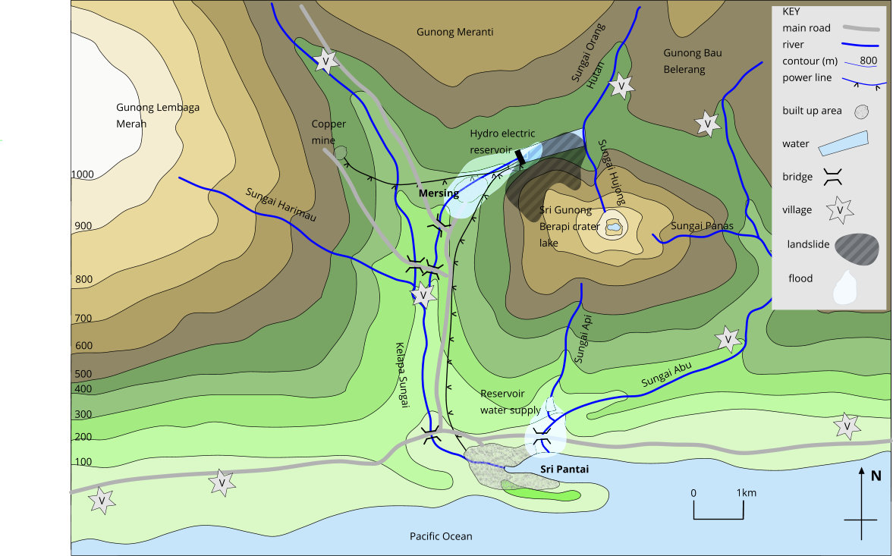
Figure 3. Areas of greatest risk from floods and landslides

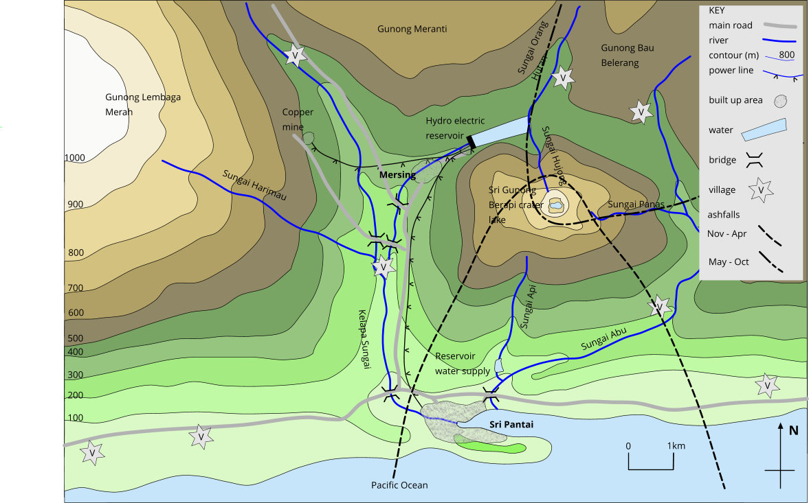
Figure 4. Areas of greatest risk from ashfall, nuées ardentes and poisonous gases

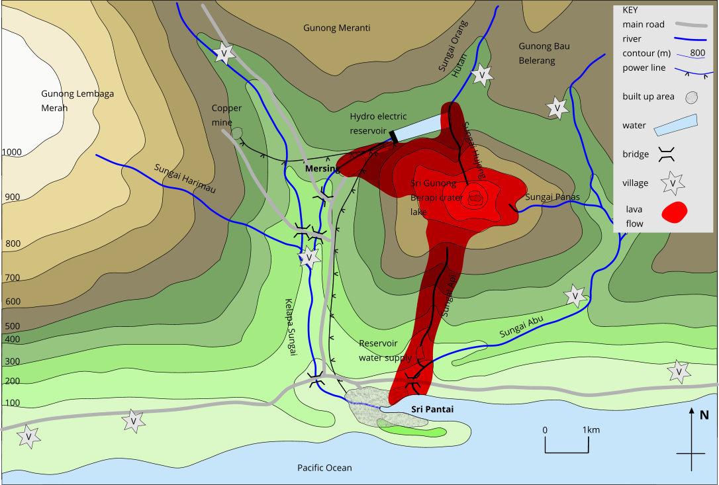
Figure 5. Areas of greatest risk from lava flows
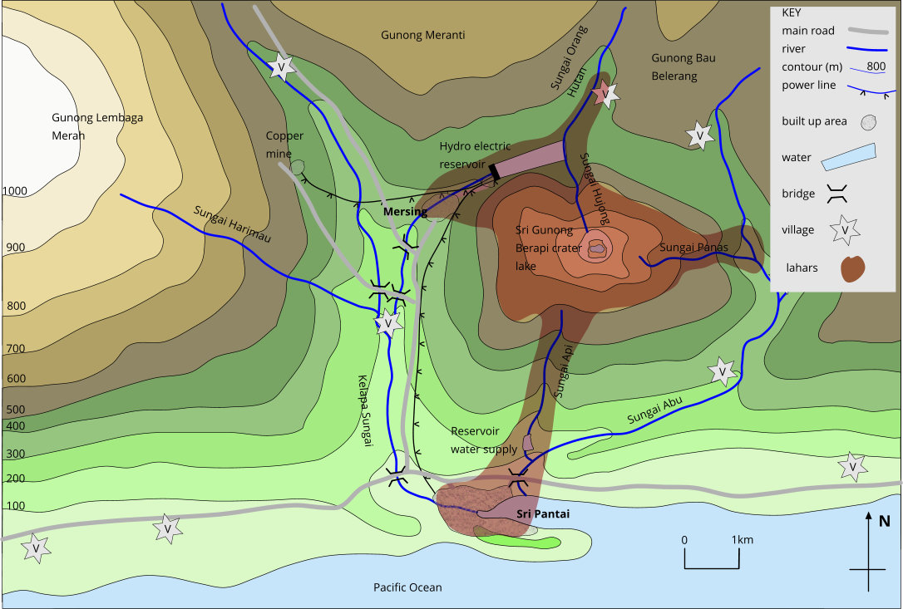
Figure 6. Areas of greatest risk from lahars
- Ash fall
Ash fall is more likely to occur than any other volcanic hazard. Several ash falls can be expected, and they may deposit anything from a few millimetres to thirty or so centimetres of ash. The area affected will depend on the wind direction and thus on the season, but both towns are so close to the volcano that both are likely to receive some ash.
People and animals may choke if they breathe in too much ash and animals may seriously abrade their teeth and stomachs if they chew vegetation with ash on it.
Crops will be killed if the ash fall is heavy, but a light dusting of ash will help fertilise the land. Animals may die if the ash completely covers the vegetation and they are unable to graze.
Roofs may collapse from the weight of ash: most roofs can withstand up to 30cm of dry ash but would collapse if this became rain-soaked. The thatched roofs of the villages are most at risk followed by the flat roofs. Pitched roofs are better able to shed the ash and its weight.
Ash will clog up the filters on the air intakes of car and lorry engines. Thick ash falls would block the roads especially after drifting. Ash may get into machinery and cause serious abrasion to moving parts. Wet ash may build up on electric wires and pull them down. Ash often clogs up water supply intakes and may make the water acid for a short while; it may also clog up sewage works causing flooding and insanitary conditions.
Preventative measures
Instructions to population to stay inside and cover mouths with damp cloth; to clear roofs as soon as possible; to cover over machinery. Government should ensure there are sufficient bulldozers to clear roads.
- Lava
Lava is likely to be emitted if the eruption is not too violent, but the lava will be viscous, and the flows will not be extensive. Any lava flow will be restricted to the flanks of the volcano and to adjacent valleys. These lava flows move very slowly and are unlikely to cause death or injury to any person or animal who can walk, but lava will destroy and bury everything in its path.
Larger flows may reach the valley bottom but would not be likely to cover any significant area of paddy fields or grazing land. If the grass in the grazing areas was long and dry, then the lava might set fire to it.
Acid and intermediate lava flows rarely travel for more than 15km. Once they reach flat open land then they stop within a short distance. Both Sri Pantai and Mersing are within range of flows coming directly down the volcano but are unlikely to be reached by flows running down the east or west side and then moving along the valleys.
Lava flows might block the main Mersing to Sri Pantai road and, more seriously, might block the harbour.
Preventative measures
Lava flows can sometimes be diverted by barriers of rubble piled 3m or so high and placed diagonally to the slope. This has been found to be most effective if the barriers are placed close to the vent. In this way flows might be directed away from the two towns. Alternatively, the lava can be cooled and solidified by pumping water on to its surface. This operation is most likely to be successful the further away from its source the flow is, so it should only be attempted if the flow is approaching Mersing and Sri Pantai. Either the hydro-electric reservoir or the sea could be used as a source of water. This technique was successfully used in 1973 to prevent the blocking of Vestmannaeyjar harbour in Iceland.
- Lahars
These are mudflows formed when loose volcanic ash becomes saturated, unstable and suddenly flows down slope. Lahars can be expected anywhere after heavy ash fall but the steepest slopes, such as above Mersing, are the most vulnerable. After starting on the slopes, they then flow down the valleys and can travel at speeds of 40-50 km h⁻¹ and no warning could be possible. They are most likely after heavy rain, or if the water in the crater is expelled over the side.
Preventative measures
Lahars will destroy and bury everything as happened at Herculaneum during the eruption of Mount Vesuvius in AD 79. They may displace the water in reservoirs and cause flooding but if the water level in the reservoirs was lowered they may trap small lahars.
- Floods
The most serious flooding would occur if the dam of the hydro-electric reservoir was breached. This could be caused by an earthquake, or by a landslide. Such a flood would, by the volume of water released, devastate Mersing and the power station killing many people. It would also cause serious flooding in Sri Pantai which is 7km downstream but, because of the flatter land and the greater width of the valley, the water would not be moving as fast. A smaller flood would be caused if the water supply reservoir dam was broken.
Floods might also be caused by displacement of the water from the reservoirs by landslides, lahars, or ash flows.
Preventative measures
The damage caused could be minimised by lowering the water levels in the reservoirs and by ensuring that the country was not wholly dependent on one generating station.
- Landslides
Landslides may be caused by a build-up of ash or lava to a point where it becomes unstable or they may result from a bulging of one side of the volcano. They are possible on any side of the volcano, but the steep north slopes are the most likely site. A major landslide could destroy either town but probably the most likely danger is from a small slip sliding into the hydro-electric reservoir and causing a flood.
A landslide might be triggered by an earthquake.
- Earthquakes
Earthquakes are commonly associated with volcanic activity and may indicate that the period of inactivity is about to end. Earthquakes preceded the AD79 eruption of Vesuvius and the Mount St. Helens eruption in 1980.
The main danger is that earthquakes may cause landslides, as happened in the 1980 volcanic eruption of Mount St. Helens. Earthquakes may also trigger lahars or cause the dam wall to crack leading to its collapse and consequent flooding. The earthquakes will be shallow focus but may cause damage to both towns. Sri Pantai, which is built on alluvial sediments, is most in danger. Some of the underground workings in the mine may collapse.
Preventative measures
Earthquake monitoring may provide a broad-based, around-the-clock monitoring system to provide warning of any future seismic activity so that appropriate steps can be taken to reduce the risk to lives and property.
- Nuées ardentes
These are glowing clouds of incandescent ash which roll down the sides of the volcano and along the valleys. The direction they leave the crater is usually determined by the wind so that Sri Pantai is in danger between November and April.
Nuées ardentes scorch everything in their path and can be expected to kill all human beings and animals, to set fire to buildings, and to burn all plants and trees.
Preventative measures
No prevention or warning is possible, but nuées ardentes are unlikely to occur.
- Volcanic gases
Volcanic gas consists of H₂O along with CO₂, HCl and SO₂. This means that they may kill or wither vegetation for tens of kilometres downwind of the volcano. Heavy gases may be trapped in hollows and kill animals and even human beings. Such an event happened in the Lake Nyos disaster in 1986, when an eruption in north western Cameroon, produced a large cloud of carbon dioxide, which descended onto nearby villages, killing 1,746 people and 3,500 livestock. More usually, the only effect will be temporary sore eyes and breathing problems.
- Lateral blast
A lateral blast could come from any side of the volcano and would destroy everything within a 150° segment in that direction for 25 or 30 km. It was a lateral blast which devastated 500 km² around Mount St. Helens in 1980 and although many other examples are known it is an unlikely event.
Preventative measures
No preventative measures are possible, but the experience gained from the study of Mount St. Helens indicates that thermal and geodetic monitoring should indicate whether a lateral blast is likely, and its possible direction.
- Major explosion
A major explosion of the type that occurred at Krakatoa is a very unlikely event but, if it happened, it would destroy the whole area.
Preventative measures
No preventative measures are possible.

Recommendations to the Government
1. The population should be told what the best course of action is in case of ash falls.
2. Bulldozers should be available to remove ash and lava from roads.
3. Pumps should be available to cool the lava.
4. Barriers should be built to deflect any lava flows.
5. The water level in the reservoirs should be lowered to the minimum working level.
6. A monitoring team should be set up to detect changes in surface temperatures, the shape of the volcano and any earth tremors.
7. The hydro-electric power station and its reservoir should be in a valley not adjacent to the volcano.
8. Further work should be undertaken to study the volcanic deposits found around the volcano. Such
studies may help in the prediction of the kind of eruption that can be expected.
References
Tuke, M. (1987) Volcanic hazards. Geology Teaching 12 (4), pp. 150-151.
Tuke, M. (1988) Volcanic hazards: solution to a worksheet. Geology Teaching 13 (2), pp. 89-91.
Maggie Williams, Department of Earth Ocean and Ecological Sciences, University of Liverpool hiatus@liverpool.ac.uk
Peter Williams, Department of Earth Ocean and Ecological Sciences, University of Liverpool tjpeter@liverpool.ac.uk

