 | Volcanic hazards | 

Introduction: Volcanic hazards
Imagine that you have been employed as a geological consultant by the Far Eastern state of Harimau, a small area of which is shown in Figure 1. The state lies close to the Republic of the Philippines at latitude 15°N and longitude 120°E. The climate is tropical with a high annual rainfall and high annual temperatures. The principal difference between the seasons is that the wind blows from the southwest between May and October and from the north from November to April.
The capital city of Harimau, Sri Pantai, lies close to the volcano of Sri Berapi which, oral tradition says, last erupted violently in the 17th century. Since then, there has been some emission of steam and sulphurous gas and a small andesite cone has been built up in the crater. Recently there have been some small earth tremors and much emission of steam.
Your task is to list and describe the possible volcanic hazards and to say what effect they may have on the economy and lives of the inhabitants of the city and of the surrounding areas. You should also produce maps showing the danger zones for each type of hazard. A wide variety of hazards is likely if you examine the map closely. The additional notes below should help you evaluate the extent and significance of these hazards, but you will need to use all the information provided in the map and reference sheet.
1. The area is self-sufficient in food because it has a large fishing fleet and much fertile land.
2. The only industries are copper mining and hardwood forestry, the products of which are exported by sea.
3. The low-lying land along the shore and valleys is mostly used for paddy fields and for grazing; the higher slopes, above two hundred metres, are all jungle and are only used for timber.
4. There are two centres of population. Sri Pantai, which is the administrative and commercial centre, has a population of about thirty thousand and lies around the harbour, and Mersing which has a population of nine thousand, lies inland and houses most of the mine labour force.
5. In the built-up areas the buildings are mostly brick and concrete, some with flat roofs and some with tiled roofs. Many people live in small villages in the countryside and their houses are mostly timber with thatched roofs.

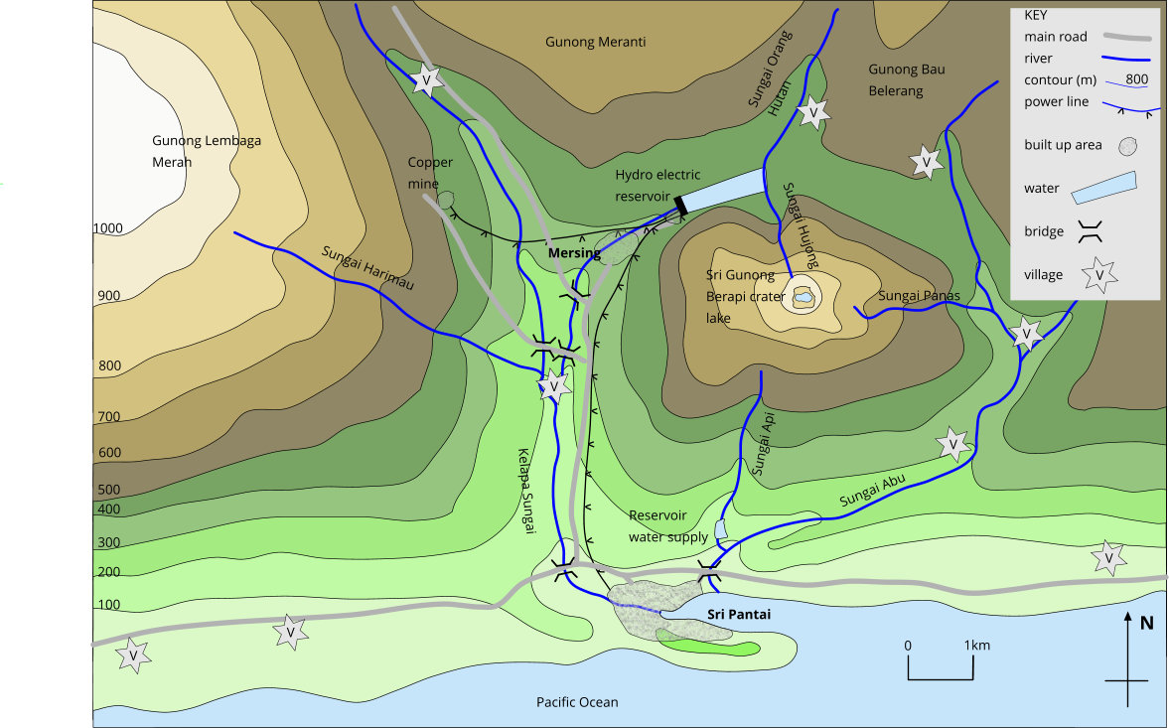
Figure 1. Location of Sri Berapi volcano with the surrounding settlements and economic developments

Reference sheet - useful sources of information about volcanoes
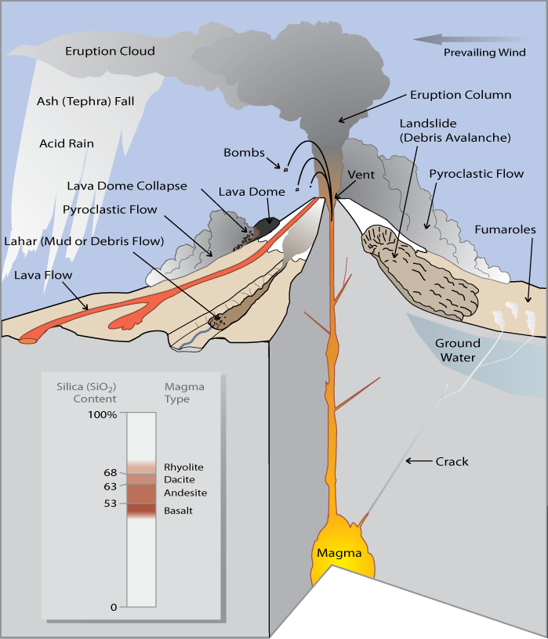  Figure 2. Simplified sketch showing how a volcano produces a wide variety of natural hazards that can kill people and destroy property.  Credit: USGS https://pubs.usgs.gov/fs/fs002-97/ | Useful websites to find out more about volcanoes and volcanic hazards  - USGS site detailing volcanic hazards such as tephra/ash, lava flows, lahars, volcanic gas, pyroclastic flows, and volcanic landslides.  https://volcanoes.usgs.gov/vhp/hazards.html  - A site where there is an outline of the many types of hazards are associated with volcanoes.  https://geology.com/volcanoes/volcanic-hazards/  - A BGS site explaining volcanoes and volcanic hazards.  https://www.bgs.ac.uk/discovering-geology/earth-hazards/volcanoes/volcanic-hazards  - YouTube clip showing a lahar, Mt Ruapehu, New Zealand, March 18, 2007.  https://www.youtube.com/watch?v=5x5tZAHEoRU  - YouTube clip showing of the 1980 Mount St. Helens volcano eruption.  https://www.youtube.com/watch?v=-H_HZVY1tT4  - YouTube clip showing a nuée ardente eruption at Sinabung, Indonesia in June 2015.  https://www.youtube.com/watch?v=GUdqQR0N2q4  - YouTube video of Mt. Pinatubo explosion at Clark Air Base, Philippines (Part 1).  https://www.youtube.com/watch?v=SMe0VPQftsc  - YouTube clip from ‘Iceland erupts’.  https://www.youtube.com/watch?v=MlH7pCK4H-s

Maggie Williams, Department of Earth Ocean and Ecological Sciences, University of Liverpool hiatus@liverpool.ac.uk
Peter Williams, Department of Earth Ocean and Ecological Sciences, University of Liverpool tjpeter@liverpool.ac.uk

