19 Nov 2018 – SENTINEL-2 MultiSpectral Instrument (visible)
B
A

10th Dec 2018 – SENTINEL-1 C-band SAR

22 Dec 2018 (8 hours after tsunami) – SENTINEL-1 C-band SAR

25 Dec 2018 – SENTINEL-1 C-band SAR
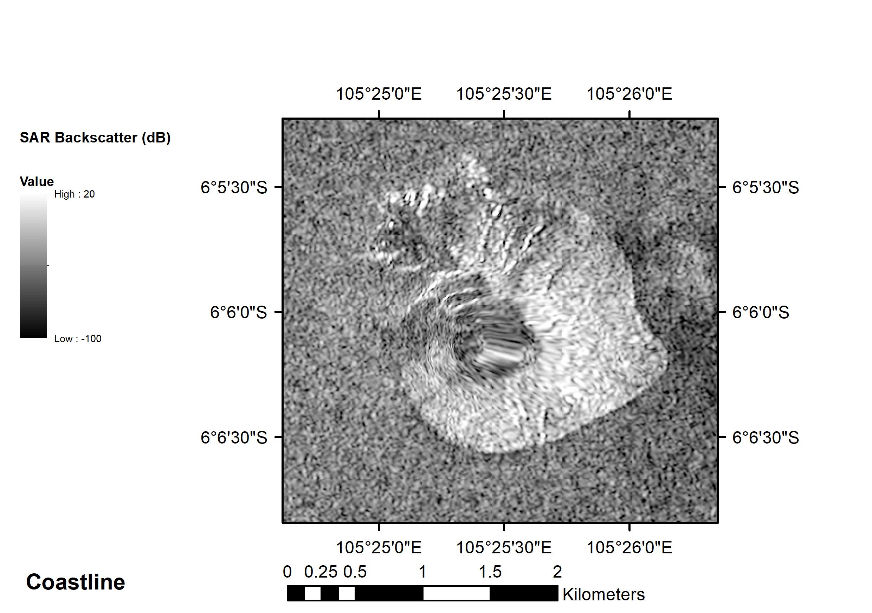

28 Dec 2018 – SENTINEL-1 C-band SAR
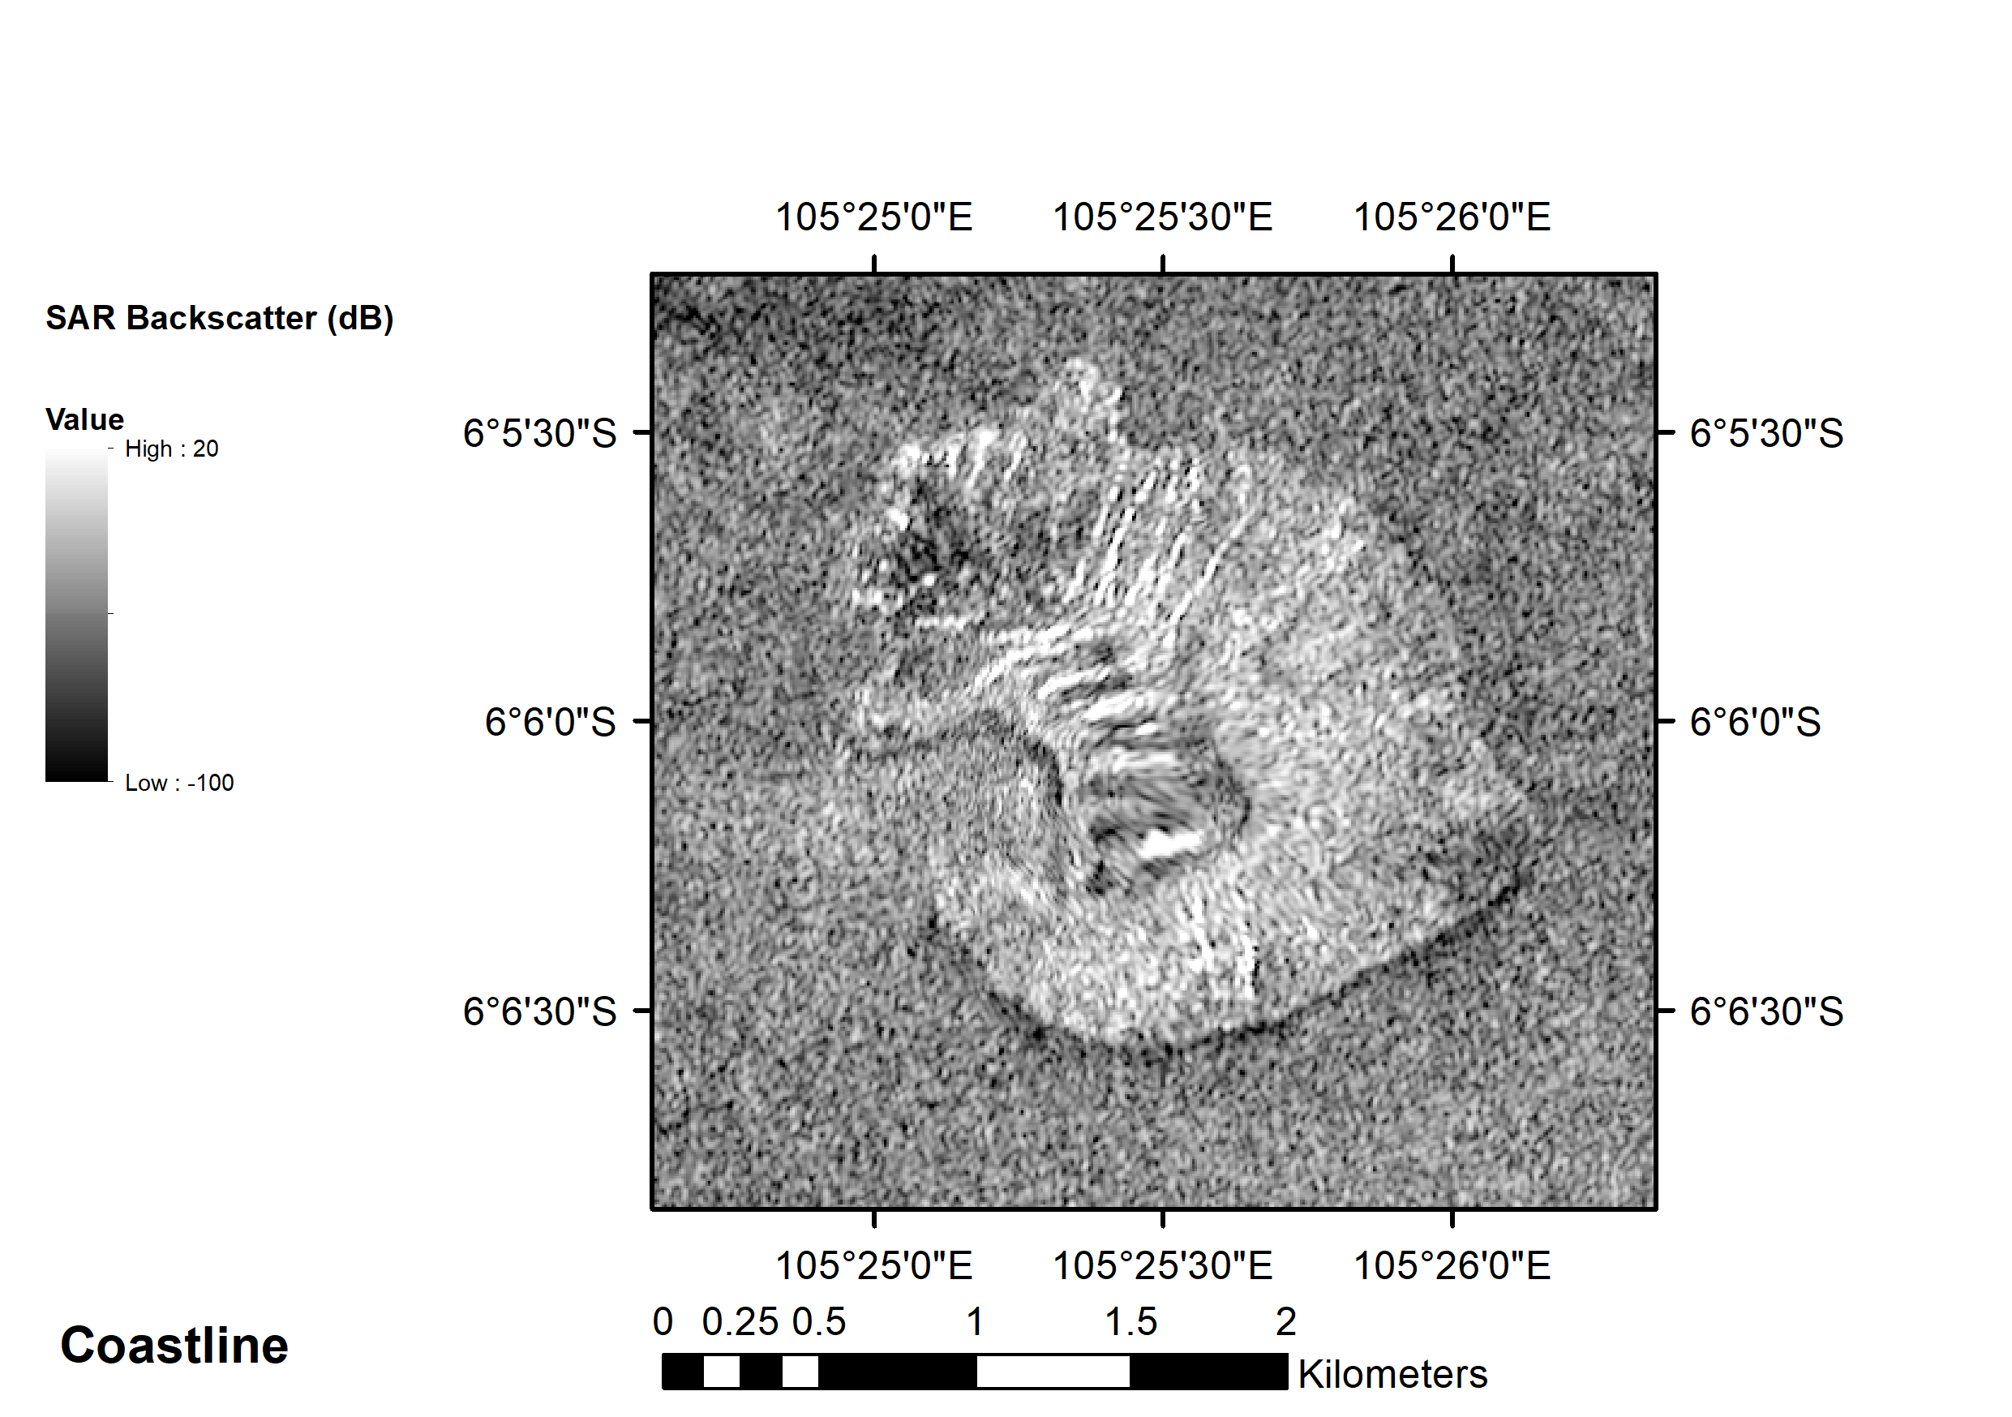

2 Feb 2019 – SENTINEL-2 MultiSpectral Instrument (visible light)

