
Reconstructing the Anak Krakatau collapse of December 2018

In this activity you will use a range of publicly accessible data to better understand the structure and failure of the Anak Krakatau volcano, which triggered the fatal tsunami on 23rd December 2018. By interpreting satellite visible spectrum and RADAR data you will infer how and where the volcano failed, and how much material was involved in the landslide that triggered the tsunami.

SAR Imagery
You have been provided with a selection of SAR images, with capture dates and times. SAR is a technique where a satellite sends out radio waves and detects their reflections. The brightness of the image correlates to how much of the radar energy is reflected back at the satellite. Objects pointing toward the satellite will reflect more energy back at the satellite. Objects pointing away will appear in shadow.
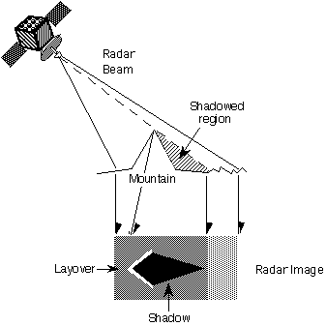
Figure 1. Synthetic Aperture Radar (SAR) brightness response

TASK 1 – Satellite imagery
Look through the provided SAR imagery, as well as the before and after visible spectrum satellite images. Think about how the shape of the island has changed with time. Discuss with your group what you think happened, and in what order.
Using the provided SAR images and tracing paper
- Draw overlapping outlines of the volcano before and after the collapse
- Mark the outline of the flank collapse. The line you mark closest to the centre of the volcano is the ‘headscarp’ along which the slope failure happened.
- Estimate the area of the volcano that was lost due to flank collapse
- Continue tracing outlines and mark the location of the volcanic vent through the time period. What is happening?

Task 2 – Calculating the volume
The failure slope was vertical at sea level, but we don’t know what form it took below water.
- Using the cross section, and the marked start of the failure, draw what you think is a likely failure surface that the landslide occurred along.
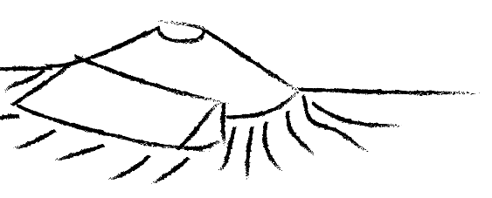
Headscarp
Figure 2 – Sketch of simplified failure model, assuming a triangular wedge
- Measure the length of the headscarp you drew in Q2.
- Estimate the cross sectional area of the failure using your failure plane drawn in Q5
- Calculate the failure volume assuming it is a simple prism ($area ×length$).
- How robust do you think your calculation is relative to the real failure volume? What are the main sources of error?
- To what precision would you be happy stating your volume estimate to?

Task 3 - Interpretation
In 2012 a paper was published which simulated a tsunami from Krakatau which was very similar to the one seen in December 2018 (Giachetti et al., 2012). They imagined 0.3 km³ collapsing from the volcano.
- How does this value compare to the one you just calculated in Q6? What does this imply?

This practical is based on Williams, Rowley, & Garthwaite 2019. Reconstructing the Anak Krakatau flank collapse that caused the December 2018 Indonesian tsunami. Geology ; 47 (10): 973–976. doi: 10.1130/G46517.1. This is available as an open access article from EarthArXiv at https://eartharxiv.org/u965c/

