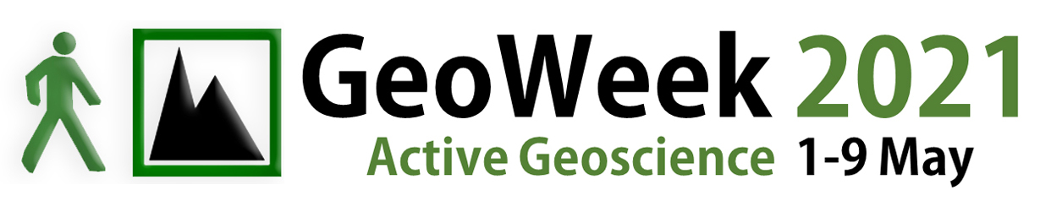
Feedback Form

We are keen to find out how you enjoyed the GeoWeek event you attended and how we can improve future events. Please take a moment to complete this questionnaire to tell us what you thought of the event. Please ✓ relevant boxes.

Did you find your visit?

Not at all enjoyable | 1 | 2 | 3 | 4 | 5 | Very enjoyable

If there were children in your group, which part of the event did the children enjoy the most?

....................................................................................................................................................................................................

The adults in your group; which part of the event did they enjoy the most?

....................................................................................................................................................................................................

Did you learn anything today that you didn’t know before?

Nothing at all | 1 | 2 | 3 | 4 | 5 | Lots!

If you did learn something, what was it that really stuck in your mind that you learnt today?

Have you been to a GeoWeek event before?

yes  no  (please specify) .................................................................................................................................

Would you be interested in attending future GeoWeek events?

yes  no 

How could we improve the event?

Where did you find out about this event?

 GeoWeek website  Leaflet/poster  Social media

 Radio  Word of mouth  Newspaper

 Other (please specify) .........................................................................................................................................................

Thank you very much for taking the time to complete this form.
Please hand the form to the event organiser.

