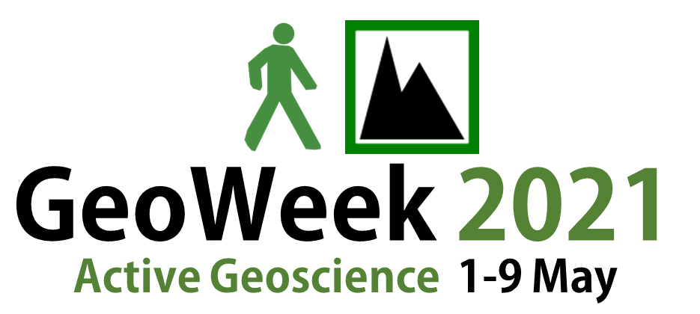Contact details, medical condition, safety instructions, photo and future contact permission
Health and safety  We take health and safety very seriously, so please sign to indicate that you have read these notes.  - Stay in earshot/’eye-shot’ of the leader at all times  - If you must leave the group for any reason, inform the leader beforehand  - Obey the country code and observe bylaws  - Be considerate of other group members and members of the public  - Everyone in the group has responsibility for everyone else’s health and safety | Medical condition  Examples of medical conditions that should be noted include, but are not restricted to: ankle/knee/hip weakness or past injury, asthma, vertigo, high blood pressure, heart conditions, claustrophobia, diabetes, epilepsy, recent illness, current medication.

Name | Email | Mobile phone | Phone number to contact in an emergency (not the one you are carrying with you!) | Medical condition |  | Permission (Yes/No) to: |  | Signature of individual (or carer if under 18) that you have read the safety notes
 |  |  |  | Yes/No | If ‘yes’ details (or speak to leader) | take photos of yourself | contact you about future geoscience activities
NB: GeoWeek is not responsible for the health and safety of events and does not insure events.
Name | Email | Mobile phone | Phone number to contact in an emergency (not the one you are carrying with you!) | Medical condition |  | Permission (Yes/No) to: |  | Signature of individual (or carer if under 18) that you have read the safety notes
 |  |  |  | Yes/No | If ‘yes’ details (or speak to leader) | take photos of yourself | contact you about future geoscience activities
NB: GeoWeek is not responsible for the health and safety of events and does not insure events.

